This document contains comments gotten from the customer at the final design stage.
Below are listed comments with pictures
- The customer loved the simplicity we put into the homepage which makes it calm when the user opens the website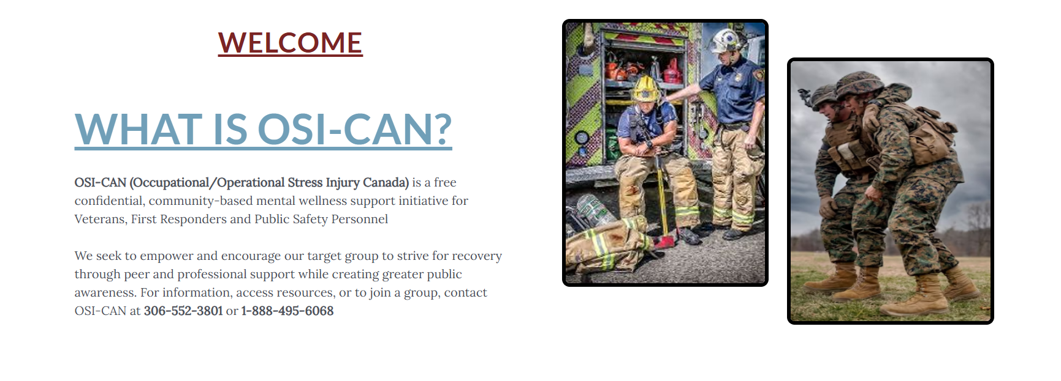
- The customer loved the grouping of payment options making it easier for the user to decide
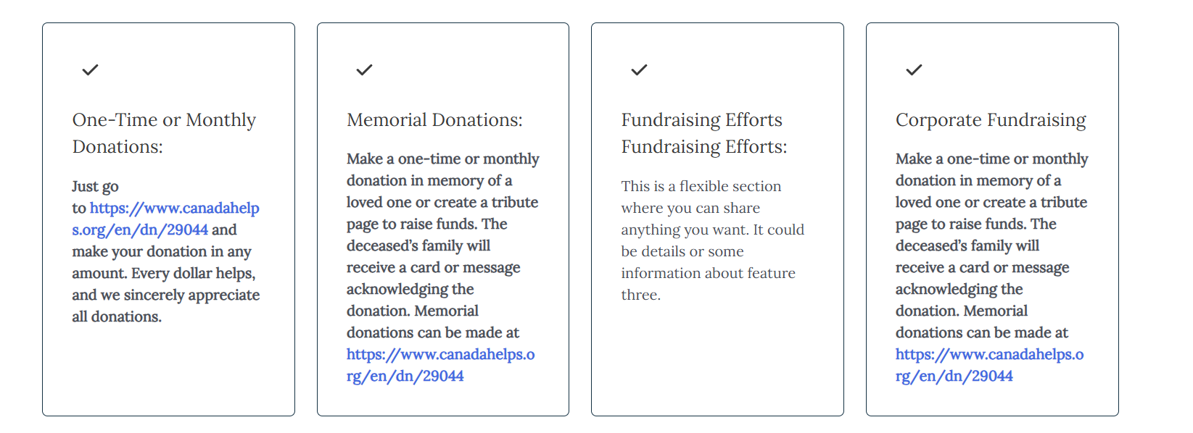
- The customer loved the border we placed border we placed around our pictures and other box layout in other to make it catchy to get the users attention
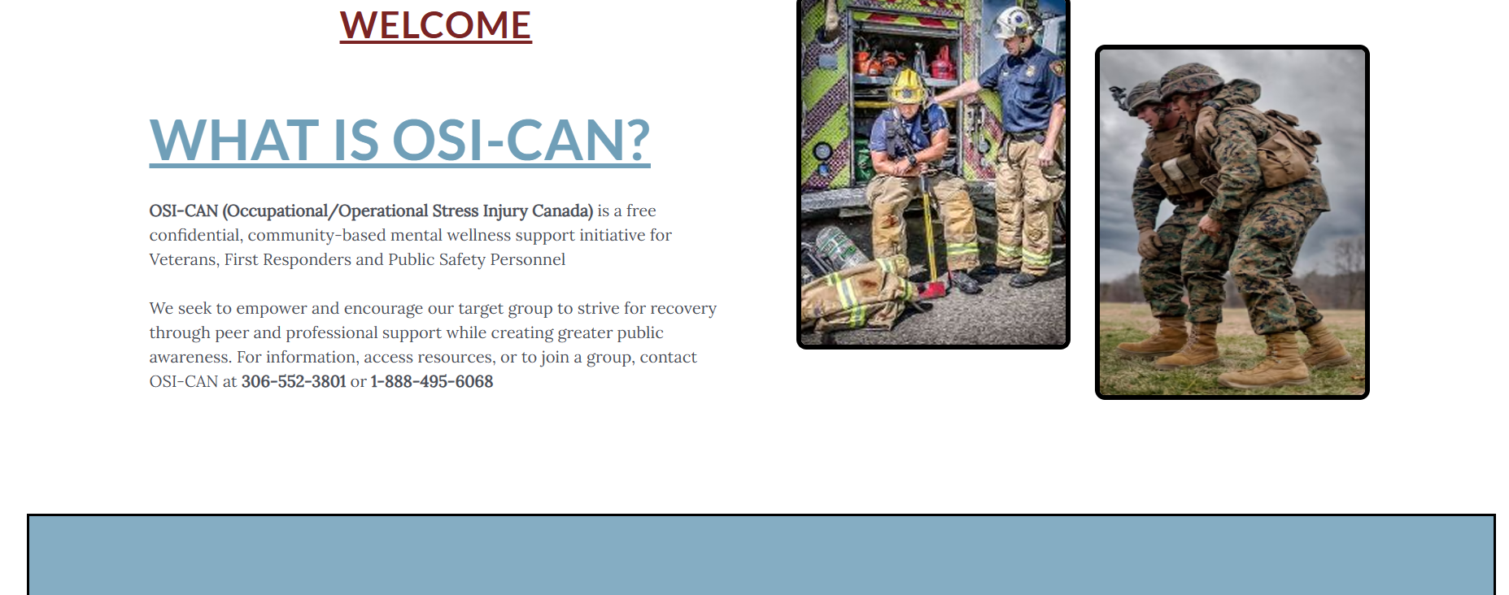
4.)The customers loved the design of the sponsor page but suggested we try next time to make the sponsors who name are text to just be text in other to help with acessbibility features
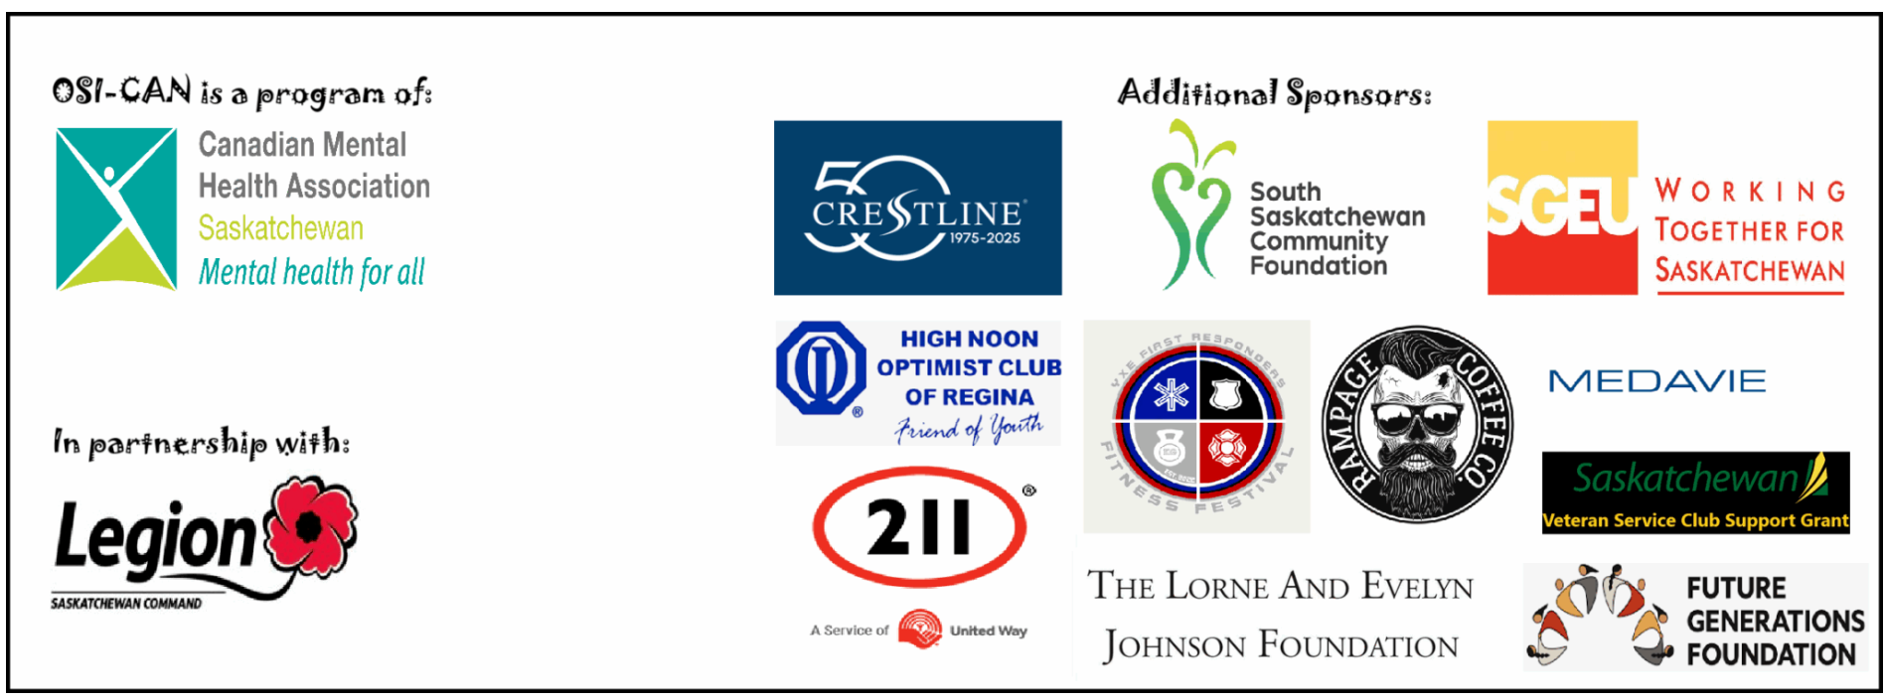
5.)The customers loved our idea of putting pictures to represent each resource in the resource page
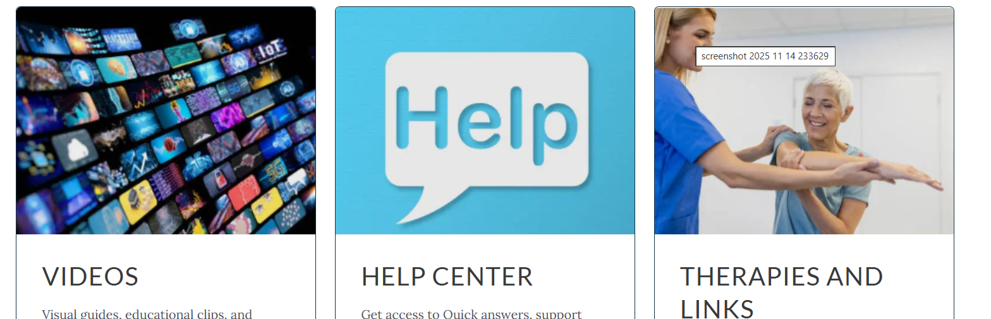
6.) The customers loved our idea of removing the sub pages option from the navigation button. This would help the user to go to the important page first then learn more about it. This might not be liked by people of the new generation but it helps targeted demographic so they easily get what they need.

